# DEDICATION

This work is dedicated to the God and to all Petroleum Engineers

# ACKNOWLEDGEMENT

My utmost gratitude goes to the God almighty, for his abundant goodness and provision in the course of my study in FUTO and in course of carrying out this project.

My deep appreciation goes to my mother, Mrs. Violet Ukachukwu and my uncles, Sir Alex and Dr. Samuel Maduako for granting me endless support.

I also appreciate the COTO staffs of DPR Port Harcourt Zone, Engr. L. Tuboalabo and Engr. Jumbo for several help they offered in the course of seeking for field data.

A special thanks to my project supervisor, Engr. B. Nzeribe for his good support and guidance in the preparation of this work.

I appreciate the Head of Department of Petroleum Engineering Department, Engr. Dr. S. Onwukwe for giving me the opportunity to get this knowledge.

Finally, I appreciate my friends: Ireke Ukiwo I., Igboke C.I., Nwakwesili Innocent and Amarachi Ugenyi for their encouragement and love throughout the work.

# **ABSTRACT**

Water flooding is an abstract enhanced oil recovery method. It is not only capital intensive but it also requires a very high level of precision before embarking on it. To determine the pattern and practices that will yield the maximum recovery possible. So there is need to check several responses of these parameters for proper decision making. This work is an analytical evaluation a real field data to investigate several parameters and their approximate outcome when the field is operated at those conditions. It contains an ECLIPSE 100 simulation, giving a dynamic model approach to water flooding.

At the end of the simulation, it was observed that out of the three patterns investigated (line drive pattern, 5-spot pattern and skewed 4-spot pattern); the 5-spot pattern yielded maximum recovery with the least amount of produced water. The skewed 4-spot having more injector well than producer well had higher produced water with a lower oil yield.

For an operator in the field used and any other field analogue to that one, it is recommended that the 5-spot pattern is employed early enough in the field for the optimum recovery to be achieved.

TABLE OF CONTENTS

**CERTIFICATION** i

DEDICATION ii

ACKNOWLEDGEMENT iii

**ABSTRACT** iv

**LIST OF FIGURES** vii

**LIST OF TABLES** viii

**CHAPTER ONE** 1

**1.0 INTRODUCTION** 1

**1.1 BACKGROUNG OF THE STUDY** 1

**1.2 STATEMENT OF PROBLEM** 3

**1.3 OBJECTIVE OF THE STUDY** 3

**1.4 SIGNIFICANCE OF THE STUDY** 5

**1.5 SCOPES AND LIMITATIONS.** 5

**CHAPTER TWO** 6

**2.0 LITERATURE REVIEW**. 6

**2.1 Water Flooding In Southern Oman (Pdo, 2015)** 10

**2.2 Injection/producer pattern layouts** 12

**2.3 Injection-water-sensitivity studies** 14

**2.4 Injection wells, injectivity, and allocation approaches** 16

**2.5 Pilot Waterflooding** 18

**2.6 Production wells** 19

**2.7 Surface facilities for injection water** 20

**2.8 Surface facilities for produced fluids** 22

**CHAPTER THREE** 25

**3.0 METHODOLOGY** 25

**3.1 Project Methodology** 25

**3.2 Simulation Objectives** 28

**3.3 Technologies Involved In the Project** 29

3.3.1 Reservoir Engineering 29

3.3.2 Completion engineering 29

3.3.3 Production Engineering 30

3.3.4 Industrial Chemistry 30

3.3.5 Computer Science and Engineering 31

**3.4 Software Consideration** 31

**3.5 Simulation Data** 32

**CHAPTER FOUR** 36

**4.0 RESULTS** 36

**4.1 Well control** 36

**4.2 Results from line drive flooding** 37

**4.3 Results from 5-Spot Flooding** 40

**4.4 Results from Skewed 4-Spot Flooding** 43

**4.5 Comparing the three flood patterns under investigation** 46

**CHAPTER FIVE** 49

**5.0 CONCLUSION AND RECOMMENDATION** 49

**5.1 Conclusion** 49

**5.1.1 Line drive** 49

**5.1.2 5-Spot flooding pattern** 50

**5.1.3 Skewed 4-spot flooding pattern**. 50

**5.2 Recommendation** 52

**REFERENCES** 53

# **LIST OF FIGURES**

Figure 2.1 Common Waterflood-pattern configurations. 13

Figure 2.2 Irregular five-spot pattern layout 14

Figure 2.3 Correct and incorrect pattern align with anisotropic permeability, or an oriented fracture system. 14

Figure 2.4 Possible injection-water sources. 15

Figure 4.1 A 3D Presentation of line drive Flood Pattern……………………..37

Figure 4.2 Graph of Field Oil Production Efficiency Against Time…………..37

Fig 4.3 Graph Of Field Total Oil Production Against Time……………...……38

Fig 4.4 Graph Of Field Pressure Against Time…………………..……………38

Figure4.5 Graph of Well Water Cut against Time 39

Figure 4.6 Graph of Field Oil Production Rate against Time 39

Figure 4.7 A 3D Presentation of 5-Spot Flood Pattern 40

Figure 4.8 Graph Fidel Oil Production Efficiency against Time 40

Figure 4. 9 Graph of Field Oil Production Rate against Time 41

Figure 4.10 Graph of Water Production Rate against Time 41

Figure 4.11 Graph of Field Total Oil Production against Time 42

Figure 4.12 Graph of Well Water Cut against Time 42

Figure 4.13 A 3D Presentation of a 4-Spot Flooding Pattern. 43

Figure 4.14 Graph Of Field Oil Production Efficiency Against Time 43

Figure 4.15 A Graph Of Field Oil Production Rate Against Time 44

Figure 4.16 A Graph Of Field Water Production Rate Against Time 44

Figure 4.17 A Graph Of Total Oil Production Against Time 45

Figure 4.18 A Graph Of Well Water Cut Against Time 45

Figure 4.19 A Graphical Comparison Of The Production Efficiency Against Time For The Patterns Of Study 46

Figure 4.20 A Graphical Comparison Of The Oil Production Rates Against Time For The Patterns Of Study 46

Figure 4.21 A Graphical Comparison Of The Total Production Against Time For The Patterns Of Study 47

Figure 4.22 A Graphical Comparison Of The Water Production Rate Against Time For The Patterns Of Study 47

Figure 4.23 A Graphical Comparison Of The Total Water Production Against Time For The Patterns Of Study 48

# **LIST OF TABLES**

**Table 3.1 Water Properties** 32

**Table 3.2 Dead oil PVT properties** 32

**Table 3.3 Saturation data 1** 33

**Table 3.4 Saturation data 2** 33

**Table 3.5 Equilibrium data specifications** 34

**Table 4.1 Well control data** 36

# **CHAPTER ONE**

# **1.0 INTRODUCTION**

## **1.1 BACKGROUNG OF THE STUDY**

In the bid to recover more hydrocarbons (oil and gas) when the natural energy/drive mechanism has been exhausted, other recovery techniques has been employed in different places to enhance production.

Traditionally, oil recovery operations have been divided into three stages: primary, secondary and tertiary recovery operations (Green and Willie, 1998).

Primary recovery resulted from the displacement energy already dominant in the reservoir (though with traces of other energy). As a boost to these energy sources in decline, secondary recovery methods like water flooding, pressure maintenance and gas injection has been introduced, though water flooding seemed to be the most dominant amongst all (Craig Jr., 1993).

The tertiary recovery system includes any other method applied to enhance production, other than water flooding and gas injection; they include: steam injection, chemical flooding, in-situ burning, miscible flooding, polymer flushing and so on (Rifaat A., et al, 2011). These tertiary recovery techniques are mainly curative because they tend to alter the chemistry of the reservoir fluid that has a negative effect on production, like viscosity.

These enhanced oil recovery works by either altering the interfacial tension, fluid mobility, fluid viscosity and wettability, swelling of oil or altering its phase composition (Alamezie, 2014).

Water flooding involves the injection of water into the reservoir for sweeping the crude oil closer to the wellbore for optimum recovery. Its popularity is accounted for by

* The general availability of water
* The relative ease at which water is injected owing to the hydraulic head it possesses in injector wells.
* The ability with which water spreads in an oil bearing formation
* Water’s efficiency in displacing oil.

The immiscible nature of water and oil enhances the uplift of oil towards the wellbore when the water is injected into the underlying aquifer. Water injection is most commonly used to enhance recovery as it boosts oil recovery to 75% -85% (Buckley,S.E.,et al, 1942).

## **1.2 STATEMENT OF PROBLEM**

Water injection is a very expensive venture (Craig F.F., 1971) and for this purpose, several behaviours and properties of prospect reservoirs should be considered before venturing into water flooding to minimize the risk of damaging the reservoir. Some of the properties and parameters to be investigated include sand continuity, reservoir temperature and pressure, reservoir fluid behaviour-saturation, porosity and permeability, initial drive mechanism, reservoir geometry and the fluid production rate deemed optimal for safety and economic viability.

Improper choice of water, injector well patterning and injection rate has led to several disadvantages in the water flooding system.

Inadequate analysis of the reservoir rock properties and time most suitable for flooding has also posed a great challenge. Some wells that are being produced under natural/dominant drive mechanism were estimated to produce for a certain length of time before reaching the optimum production for decline, but unfortunately could not meet the forecast.

These insufficiencies, negligence, inappropriate choices and cost of drilling injector wells constitute problems in the Nigerian oil and gas industry.

## **1.3 OBJECTIVE OF THE STUDY**

This works aims at applying a dynamic model approach in tackling the problems stated in 1.2. It applies the modern 3-D models and simulation approach to test and consider the challenging parameters, placing them to different conditions for better decision taking before venturing into this capital intensive injector well program.

It also aims at dynamically predicting the more effective approaches to water injector well patterning and carrying out literature search to improve on the works already done on enhanced oil recovery.

## **1.4 SIGNIFICANCE OF THE STUDY**

The purpose of every venture, which oil and gas exploitation is part of, is to make profit. Water flooding is significant in maximising production, increasing the lifespan of a field, and improving profit making.

At achievement of the objectives of this study, better decision on parameter handling and choice of patterns and materials will be made effectively, and the ultimate aims of water flooding will be achieved.

This study will also broaden our views of simulation from the usual correlation models to a dynamic and graphical 3-D modelling creating more rooms for investigating parameters for more favourable real life application in the field.

## **1.5 SCOPES AND LIMITATIONS.**

This work is based on research and simulation, and therefore, will encompass only known parameters and results achievable with the applied software, ECLIPSE.

It is limited to water flooding as a secondary enhanced oil recovery method, choice of water and model creation for field application and knowledge purposes.

This work also evaluates already done works and modifies some using the dynamic approach, hence not a work of invention or discovery work.

# **CHAPTER TWO**

# **2.0 LITERATURE REVIEW**.

Waterflooding is the oldest and by far the most important method used by the petroleum industry to increase recovery from both onshore and offshore reservoirs. Waterflood design is a complex problem that must ultimately be handled on an individual reservoir basis. This project presents factors that should be considered in designing both onshore and offshore water floods.

The need for careful examination of the following factors is considered and discussed in this work;

1. Reservoir geology and method of deposition

2. Primary production mechanisms and stage of depletion

3. Reservoir and fluid properties

4. Reservoir pressure

5. Well spacing and possible Waterflood patterns

After these factors are discussed, the effects that pattern selection, timing and injection/producing rates have on project economics arm discussed. A special emphasis is placed on offshore Waterflooding since it is now of significant concern.

Waterflooding was first used over 100 years ago, but it was not until the 1950's that it gained popularity when field applications increased at rapid rate. At the present time, Waterflooding is so well regarded as a reliable and economic oil recovery technique that almost every field that does not have natural water drive, is being or soon will be water flooded. Waterflood projects from a reservoir engineering view point are very tedious and require detailed data. There are two basic classifications of water injection projects:

1. Waterflooding - those which displace oil from semi-depleted and depleted reservoirs, that is, increasing recovery through the more efficient displacement process.
2. Pressure maintenance - those which maintain a pressure in new or partially depleted reservoirs for sustaining the production rate.

The main difference between secondary recovery (Waterflooding) and pressure maintenance operations is the amount of reservoir pressure existing at the time the operations are begun. If the reservoir pressure is fairly high, the operation is called pressure maintenance, but, if the pressure has been substantially depleted, the operation is called secondary recovery. Both operations should increase ultimate recovery from the affected reservoir. Under normal circumstances, pressure maintenance operations will not bring about then rate increase that a Waterflood will since it is installed when the reservoir producing rate is at higher level. Many factors important to Waterflooding are also important to pressure maintenance, so that it is difficult to define a definite point of separation between the two processes.

Discovery of water flooding as an enhanced oil recovery technique has remained a breakthrough in the oil and gas industry as it boosts productions and reduces residual oil saturation. Classified as a secondary oil recovery method, it is introduced as a boost to the initial drive mechanism resident in the reservoir or as a sweep mechanism depending on the sinking and the location

Several studies have been done on water flooding and several models (mathematical and empirical) have been suggested. Theories have been postulated and philosophies put forward concerning the science and practice of water flooding.

According to Gullick, E. Karl, et al(2003), one of the cheapest and most popular methods of restoring and maintaining reservoir energy is by injecting water into the reservoir (i.e. water flooding). They went further to explain that many of the world’s reservoir produce by solution gas drive mechanism and this drive mechanism has inherently low reservoir energy which usually leave a large portion of the original oil in place(OIIP), when the well has reached its economically viable limit. In addition, many of these reservoirs are not homogenous in terms of pressure, and fluid content.

In their research, they acknowledged that the process of water flooding has been on for over 50 years and they thereafter put forward some philosophical inferences (inductions and deductions) that they termed,” the key tenets of a successful water flooding water flooding. They are,

* Start the water flooding early in the field’s life.
* Understand the reservoir geology
* Infill drill to reduce lateral pay discontinuity
* Develop the field with a pattern of water flooding that has one injector well per producing well.
* Keep all producing well pumped off
* Inject below the formation parting pressure.
* Inject clean water
* Operate the water flood based on the injector well test
* Conduct a surveillance program

The above recommendations suggest the safer and best practice of water flooding (Ideally).

**Willie, G. Paul (1986)** also in his book, **“Water Flooding”**, tagged water flooding as a secondary recovery(like Gallic et al) because the process of water flooding yields a second batch oil after a field was depleted by primary production. He also said that water flooding has spread slowly throughout his oil producing provinces.

Willie also induced that the practice of water injection expanded rapidly after 1921(the year that water flooding was legalised in the petroleum industry). As at the time when “line” flooding replaced circle-flood, and as at 1928 was also replaced by the “five-spot” flood pattern.

He also emphasized that water flooding is the most applied enhanced oil recovery and that other recovery techniques are planned for future recovery or for curative purposes.

## **2.1 Water Flooding In Southern Oman (Pdo, 2015)**

Waterflooding has increased oil production from Nimr-C field in southern Oman sixfold in 4 years, Petroleum Development Oman (PDO) reported.

The field produced 17,600 b/d in 2014compared with 2,800 b/d in 2010. Peak production had been 13,800 b/d more than 20 years ago.

Nimr-C came on stream in 1987 but had suffered production declines because of falling reservoir pressure. The turnaround was achieved by injecting large volumes of produced water through the field “to recover the highly viscous oil.” Water injection has been accompanied by additional infill producer wells. PDO said the $600 million project could result in production of 43 million bbl. of incremental oil reserves.

“The Nimr-C team has realized millions of dollars for Oman by reviving declining field and actively managing the project risks,” said Raoul Restucci, PDO managing director.

**Rose C., et al** in their research article about water flood design wrote that the design of a water flood has many phases:

First, simple engineering evaluation techniques are used to determine whether the reservoir meets the minimum technical and economic criteria for a successful water flood. If so, then more-detailed technical calculations are made. These include the full range of engineering and geoscience studies. The geologists must develop as complete an understanding as possible of the internal character of the pay intervals and of the continuity of nonpaid intervals. This preflood understanding often is limited because the injector/producer wells connectivity has not been determined quantitatively (Reference was on Thieken, 2004). Interference testing can provide insight into connectivity when its cost is justifiable. Data gathered from smart wells can be particularly helpful in determining connectivity in high-cost environments where there is a limited number of wellbores. Analogs also can prove useful.

Otherwise, little definitive data will be available until after there has been significant fluid movement from the injectors toward the producers.

The engineer will make a number of reservoir calculations to determine the well spacing and pattern style that will be used in a particular flood. These choices are based on the available understanding of the reservoir geology, the proposed design of surface facilities (particularly water-injection volumes),and any potential limits on the numbers of injectors and producers. Such factors are interrelated in terms of capital and operating costs and oil-, water-, and gas-producing rates to define the overall economics of the project.

In making these preliminary calculations, facility capacities need to be flexible because as the Waterflood progresses, there almost certainly will be modifications to the original designs and operating plans.

In this project, a number of Waterflood design considerations will be discussed briefly. The design aspects discussed below include

* Injection/producer pattern layouts
* Injection-water sensitivity studies
* Injection wells, injectivity, and allocation approaches, including well fracturing
* Pilot Waterflooding
* Production wells
* Surface facilities for injection water
* Surface facilities for produced fluids

## **2.2 Injection/producer pattern layouts**

Fig. 2.1 shows a variety of injector/producer pattern layouts that can be considered. In reality, the existing wellbore locations might limit the pattern layout to a no symmetrical arrangement like that shown in Fig. 2.2. Also, as shown in Fig.2.3, the orientation of the rows of producers and injectors must take into account any permeability anisotropy and natural-fracture orientation. At offshore locations, the number of well slots on the drilling platforms limits the number of producers and injectors and their layout

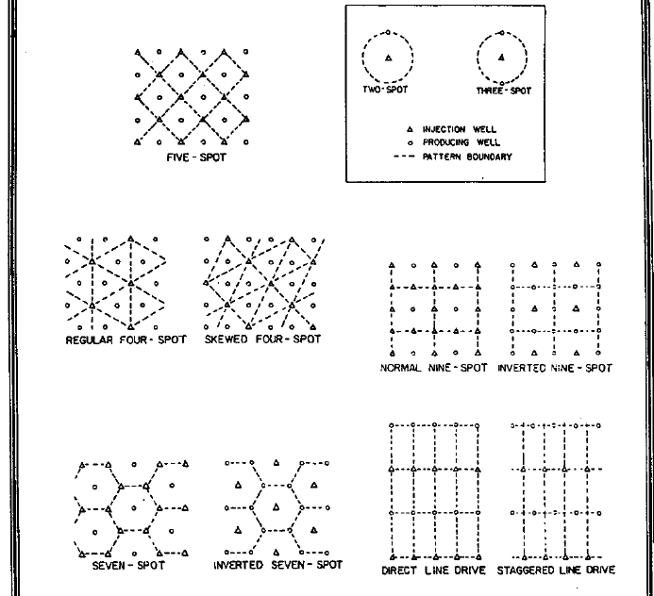

Figure 2.1 Common Waterflood-pattern configurations.

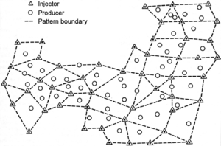

Figure 2.2 Irregular five-spot pattern layout

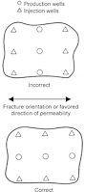

Figure 2.3 Correct and incorrect pattern align with anisotropic permeability, or an oriented fracture system.

## **2.3 Injection-water-sensitivity studies**

The factors to which injection-water-sensitivity studies relate are water-source and volume options, source water/connate water compatibility, and source water/reservoir rock interactions. After the preliminary reservoir evaluation indicates that Waterflooding is likely to be economically justified and that it will increase significantly the volume of oil recovered, the next consideration is to find an acceptable source from which to obtain enough water for the proposed Waterflood project. Fig.2.4 schematically shows the variety of natural sources for such water. Onshore locations typically obtain injection water from subsurface aquifer intervals or nearby streams or rivers. Nearshore and offshore Waterflood projects typically use sea water.

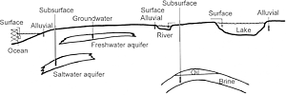

Figure 2.4 Possible injection-water sources.

Source water/connate water compatibility mainly concerns whether mixing the two waters causes any precipitation of insoluble carbonate or sulphate compounds that might impair reservoir permeability. Although permeability impairment typically is not a major consideration, precipitation and scale buildup in pumps and other surface water-handling equipment can cause costly downtime and repairs.

Potential sensitivity of the reservoir pay intervals to the injection water is a major consideration. For sandstone reservoirs that contain various types of clay, the key consideration is whether there exists clay sensitivity to the difference between the connate water salinity and the injection-water salinity, particularly for freshwater injection water sources. Such sensitivity can occur either as clay swelling or as mobilization of clay fines, both of which can reduce reservoir permeability significantly. For high-porosity chalk reservoirs, the injection water/reservoir rock interaction might weaken the rock framework and cause pore collapse and surface subsidence.

Another aspect of injection water sensitivity is the amount and size of suspended particulate being carried by the injection water. This is concern mainly when using surface water sources for the injection water. An example of where this is a significant consideration is the Kuparuk oil field on the North Slope of Alaska, US, where nearshore ocean water is the Waterflood injection water. There, the spring runoff down the rivers from the Brooks

Mountains can cause the nearshore ocean water to contain unacceptable amounts of solid particulate for several weeks of the year.

Similar problems occur in the Gulf of Mexico infields near the mouth of the Mississippi River. Also in the Gulf of Mexico, water that is drawn from too near the surface often contains organic matter that can reduce injectivity.

## **2.4 Injection wells, injectivity, and allocation approaches**

Several aspects of the design and operation of water injection wells are critical to their success. The first is that these wells must have sufficient injectivity to flow the desired volume of water into the reservoir each day. The expected injectivity can be calculated on the basis of routine core analysis, special core analysis and/or log data, and the existing production wells’ productivity; however, well injectivity often is not known until water actually is injected into the reservoir interval. This is because the near-wellbore "skin" (rock volume of reduced permeability around the wellbore) is not known until an actual well test is conducted. Injection wells can be fractured to eliminate positive skin in the near-wellbore region; however, fracturing must be done carefully to avoid fracturing out of the reservoir interval and into adjacent porous and permeable intervals into which injection water can be lost.

An aspect of well injectivity that has been studied during the last 20 years is the change in rock stresses that is caused by the cooling effect of the injection water on the near-wellbore region around injectors. This happens particularly in Arctic and offshore Waterflood operations, where the injection-water temperatures can be considerably below the reservoir temperature (i.e., more than 100°Fdifference). Perkins and Gonzalez have studied this phenomenon and found that the cooling effect reduces the earth stresses by several hundred psi. Hence, in the reservoir, a small area around water injectors’ wellbores will fracture more easily, giving that area enhanced permeability (or negative skin).

For the Prudhoe Bay field on the North Slope of Alaska, US, the fracture gradient was reduced to as low as 0.50 psi/ft. from the original fracture gradient of 0.60 to 0.70 psi/ft.

Another critical aspect of water injection well design and operation is the allocation of water to zones being water flooded. Having the ability to allocate injection water as desired to the various water flooded intervals is important for Waterflood success because the overall Waterflood is controlled primarily at the injection wells, not at the production wells.

This is not an issue if there is only one reservoir interval, but in many oil fields, there are multiple reservoir intervals being water flooded at the same time. If possible, the injection well bottom hole tubing, packer, and perforation configuration should be designed tallow control of the relative volumes of water that are injected into the various intervals being water flooded. This can be accomplished if each injection well is perforated in only one reservoir interval, but one reservoir interval per injector is unlikely to be cost-effective compared to the alternative of fewer wells with more-complicated arrangements of chokes, tubing strings, and packers, particularly if there are multiple pay intervals stacked on top of each other.

Optimum completion design is site-specific and must be based on mechanical and reservoir characteristics for the project at hand.

## **2.5 Pilot Waterflooding**

Pilot water floods seldom are used today because of the wealth of experience in Waterflooding; however, in many situations, they have been conducted to provide more quantitative data on the potential for successful Waterflooding on a field wide scale. Such pilot water floods definitely provide useful data concerning water injectivity, tendencies for early water breakthrough, and additional recovery potential. Determining recovery potential requires a pilot Waterflood that is designed to represent what will happen in full-scale application. Too often, one-pattern pilot water floods have been conducted that do not represent the confined injection/production relationship that is needed. Also, if the pilot Waterflood is conducted on a well spacing that is considerably smaller than that used for the full-field Waterflood (so that injector/producer connectivity data can be obtained sooner), the information it provides might be misleading about the injector/producer connectivity on the larger well spacing of the full-field Waterflood. Thus, definitive objectives of a pilot Waterflood should be established, and the pilot project should be designed and operated accordingly.

## **2.6 Production wells**

In many cases, the water injection wells are drilled as new wells; however, the production wells typically are those that already are producing from the oil field. For Waterflooding, producers should be completed in the same intervals in which the injection wells are completed. If the production wells are completed in several reservoir intervals, it is best to have sufficient length between the perforated reservoir intervals to allow work over operations to shut off those intervals that are producing much water and little oil by either cement-squeeze operations or by setting packer in the production tubing.

## **2.7 Surface facilities for injection water**

Maintaining high water quality is important for sustaining injectivity, reducing corrosion related costs, and minimizing equipment plugging. The American Petroleum Institute (API) has published recommendations for analysis of oilfield waters and for biological analysis of injection waters. The industry also has adopted standardized procedures for membrane/filterability tests.

The water injection surface facilities prepare the water chemically for injection and pressure the water to the desired wellhead injection pressure. Depending on the source of the injection water, the water might need treatment to remove oxygen, prevent scale and corrosion, and chelate the iron. It also might need microbiological treatment and to be filtered to remove particulates. What injection-water preparation techniques are used will vary from one Waterflood project to the next. This work specifically discusses surface and produced waters, but the techniques that are covered here also are applicable to water that is produced from aquifers.

One major consideration in injection water treatment is to prevent the reservoir from being “inoculated" with sulphate-reducing bacteria that can cause a reservoir to develop an in-situH S concentration during the Waterflood. This particularly is a problem when using ocean water, which contains both the sulphate-reducing bacteria and the sulphate ions that are their food supply. Once the sulphate-reducing bacteria have been introduced into a reservoir, they are essentially impossible to kill; however, they can be controlled with the injection of bactericides such as formaldehyde.

Pressuring water to the desired injection pressure is the final step before it is piped tithe injection wells. The wellhead injection pressure is calculated by subtracting the weight of the injection-water column from the desired bottomhole pressure, and then adding friction-flow pressure losses down the wellbore.

In a few reservoir situations, "dumpflooding" has been practiced. This is where a water-bearing formation above or below the oil reservoir is perforated, as is the oil-reservoir interval in those same wellbores. Water then is allowed to flow directly from the water-bearing formation into the oil-bearing formation, without ever bringing that water to the surface for any treating or pumping. This is a very simple approach to Waterflooding, but generally it has been unsuccessful because the rate of water injection is uncontrolled and limited to the pressure difference between the two formations, which decreases with time as the water-bearing interval is depleted, particularly near the wellbore, and as the oil reservoir interval near the wellbore pressures up.

## **2.8 Surface facilities for produced fluids**

The facilities for handling produced fluids for Waterflood must be designed with considerable flexibility. These facilities must handle a wide range of gas-, oil-, and water-production rates over the course of the Waterflood, typically period of several decades.

Initially, the production wells are likely to handle only oil and gas, without water production. When water breakthrough occurs, the water volumes will increase and, over time, water will become the great majority of the produced fluids. Accordingly, a variety of water issues must be considered. First is whether the produced fluids can be separated easily or must be treated with heat and/or chemicals in the surface equipment to achieve the desired level of separation. Second is whether the precipitation of scale in the producing wells or the production surface facilities is causing complications. Regarding scaling tendencies and because of increasing environmental concerns, the handling of naturally occurring radioactive materials (NORMs) has become an issue with respect to produced water discharges.

Over the duration of a Waterflood and as produced water volumes increase, there is likely to be the need and desire to re-inject the produced water. In this situation, the produced water must be treated so that its oil and particulate content is sufficiently small that, when the water is re-injected, these very small oil droplets will not reduce the injectivity of the water injectors. Oil fields in the North Sea and on Alaska’s North Slope have had to re-inject large volumes of produced water. Regarding injectivity losses, experimental core flood data tend to be more pessimistic than is actual injector performance in the field.

In all cases, to re-inject produced water successfully, that water must be treated to meet specifications determined to minimize those injectivity losses.

**Eric C. Robertson** in his paper in the 2010 SPE Annual Technical Conference

And Exhibition, “Oil Recovery Increases by Low-Salinity Flooding: Minnelusa and Green River Formations” emphasized on the relevance of using a low-salinity water for more recovery of the oil in place. Different wetting states of crude oil, brine, and rock ensembles can yield widely different oil recoveries during laboratory Waterflood tests. The wettability of a rock and fluids system can be altered in a number of ways: for example, changing crude oil composition, changing the aging temperature of the rock with crude oil, or by changing the temperature of displacement. The initial water saturation has a dominant effect on the wettability states induced by adsorption from crude oil because the distribution of water determines which parts of the rock surface are contacted by the oil. It has also been observed that brine composition could have a significant impact on oil recovery. It follows that there may be cases where attention to brine composition could lead to increased oil recovery and greater economic profitability of a Waterflood.

At the start of a Waterflood, water from the cheapest source (usually different in composition to the formation water) is used as the injection water, provided injectivity is not adversely affected by formation damage. Historically, little consideration has been given in reservoir engineering practice to the effect of injection brine composition on Waterflood displacement efficiency or to the possibility of increased oil recovery through manipulation of the composition of the injected water. Most laboratory relative permeability tests and displacement tests are done using synthetic formation water as both the connate and injected brine rather than using formation connate brine and the actual field injection water.

There may be many possibilities for improving oil recovery by manipulation of the injection brine chemistry, but dilution of the injection brine appears the most promising with respect to near term field application. Several examples of improved recovery by injection of low ionic strength brine have been reported for both outcrop and field core samples

**Tang (1998)** showed three conditions were necessary for increased recovery:

1. The crude oil must contain polar compounds that can be adsorbed on onto the rock surface,

2. Clay must make up a portion of the rock, and

3.The water saturation must be greater than zero.

**Robertson et al. (2003)** demonstrated that not every crude-oil/brine/rock (COBR) system is amenable to low-salinity flooding and that great care should be taken when selecting rock used for experimentation. They experimented with two well-studied COBR systems previously shown in the laboratory to recover more oil from low-salinity Waterflooding than using connate water.

# **CHAPTER THREE**

# **3.0 METHODOLOGY**

In this chapter of this work, the empirical research was carried out on pieces of data gathered from a field. It contains the approaches taken to ensure a purposeful study. This research employed a simulation study using software to evaluate several parameters of the reservoir of interest. This helps us to come up with the choice of Waterflooding approach for:

* Maximum recover
* Least water production
* Longer economic life span of the field.

Therefore, carefully selected, analysed and certified software have been chosen for this study.

## **3.1 Project Methodology**

This study was arranged into three main stages: Data collection and analysis, data processing, result assessments and approval.

RESULTS AND DECISIONS

MODIFY DATA

INPUT

COLLECTION OF DATA

PROCESSING

DATA ANALYSIS

RESULT DESIREABLE?

NO?

YES?

## **3.2 Simulation Objectives**

The main general objective of this simulation study are is to be able to use a dynamic study program and an integrated program and environment to carry out a productivity test on the field being produced through water flooding as an enhanced oil recovery.

Specifically, this simulation study revealed the effect of

* Injection rate
* Injection pattern

to the effectiveness of water flooding and to the overall water encroachment problem evaluation.

At the end of the study, chat and graphs must have been plotted to show the relationship between the above factors and the well performance with respect to time.

Also at the end of the study, we would have deduced the optimum injection rate and the best injection pattern (injector-producer well arrangement) for maximum recovery and efficient sweeping.

## **3.3 Technologies Involved In the Project**

As petroleum engineering is fragmented into several areas of specialisation, technologies and ideas from these fragments were employed to ensure the effectiveness of this study.

### 3.3.1 Reservoir Engineering

The idea from reservoir engineering

* Enables us to understand the behaviour of fluid in the formation.
* Provides us with the PVT data of the formation of the field.
* It also provides us with the volume of the crude oil in place at any point in time in the field’s life and helps in the decision of the injection commencement
* Also provides us with the porosity and permeability parameters about the formation of the field
* It also provides us with the several well arrangement options applicable in field with the stipulated fluid and rock properties.

### 3.3.2 Completion engineering

The ideas from completion engineer

* gives the proper fittings and equipment required for a proper injection
* provides us with several pump options for efficient injection

### 3.3.3 Production Engineering

Ideas from production engineering

* Provides us with the decision making platform, if the well is to be and injector or a producer and if the injection is for water flooding or for disposal.
* Provides us with the production parameters and data including; the pressure decline relationship with time as well as the GOR, BS&W and the bottom hole flowing pressure at every point in time in the field’s life.
* Also provides us with several rate options for efficient production
* Gives us the maximum injection rate after evaluation the rock properties to avoid formation damage.
* Provides also the patterns for injection and the optimisation measures for efficient sweep.

### 3.3.4 Industrial Chemistry

Ideas from industrial chemistry help us to understand the content of the injection water and also enable us to treat it properly to be suitable for proper injection.

### 3.3.5 Computer Science and Engineering

The bulk of the work has basis on software programming and simulations. The software used for this work has its operation basis on computer engineering and programming.

## **3.4 Software Consideration**

Eclipse 100 is designed to carry out a simulation study on several well functions. For the sake of this project, it is used for the following:

* Analysing the provided live data from a well in the Nigerian Niger delta
* Simulating the desired study with respect to the objectives in place.
* Providing a 3-D representation on the dynamic models of the data under investigation
* Presenting graphical relations of several subjects of investigation
* Providing enough competent and comparable information for an adequate decision making process and for proper recommendations.
* Being able to change some parameters for critical analysis in the course of further simulations
* Being able to store (save) the provided data and prospect result for future reference.

## **3.5 Simulation Data**

The data for this project were gotten from a well in the Nigerian Niger Delta fields that have produced for 12 years.

Data Security: classified and patent

Fluid type: dead oil (with no gas production, the well is produced above bubble point pressure)

**Table 3.1 Water Properties**

|  |  |  |  |
| --- | --- | --- | --- |
| Pressure (psia) | Bw(rb/stb) | Cw(psi-1) | Viscosity |
| 4500 | 1.02 | 3e-006 | 0.8 |

Rock compressibility at 4500psi: 0.0000040psi-1

**Table 3.2 Dead oil PVT properties**

|  |  |  |  |
| --- | --- | --- | --- |
| Row | Pressure(psia) | FVF(rb/stb) | Viscosity(cp) |
| 1 | 300 | 1.25 | 1 |
| 2 | 800 | 1.2 | 1.1 |
| 3 | 6000 | 1.15 | 2 |

**Special Core Analysis**

**Table 3.3 Saturation data 1**

|  |  |  |  |  |
| --- | --- | --- | --- | --- |
| Row | S­w | Krw | Kro | Pc |
| 1 | 0.15 | 0 | 0.9 | 4 |
| 2 | 0.45 | 0.2 | 0.3 | 0.8 |
| 3 | 0.68 | 0.4 | 0.1 | 0.2 |
| 4 | 8 | 0.55 | 0 | 0.1 |
| 5 | 1 | 1 | 0 | 0 |

**Table 3.4 Saturation data 2**

|  |  |  |  |  |
| --- | --- | --- | --- | --- |
| Row | Sw | Krw | K­rw | PC |
| 1 | 0.25 | 0 | 0.9 | 9 |
| 2 | 0.5 | 0.2 | 0.3 | 1.8 |
| 3 | 0.7 | 0.4 | 0.1 | 0.45 |
| 4 | 0.8 | 0.55 | 0 | 0.22 |
| 5 | 1 | 1 | 0 | 0 |

**Grid properties**

Depth from the top: 8000ft

z-grid dimension: 50ft

y-grid dimension: 500ft

x-grid dimension: 500ft

Net Gross thickness ratio: 0.95

Permeability range: 100mD-1000mD

Porosity: 0.19-0.20

Water density at surface condition: 63lbs/cf

Oil density at surface: 49 lbs/cf

**Table 3.5 Equilibrium data specifications**

|  |  |  |
| --- | --- | --- |
| Datum(ft) | Pressure(psia) | Oil water contact(ft) |
| 8000 | 4500 | 8075 |

*the model used was FETKIVICH AQUIFER MODEL

Grid properties for simulation (GRID MODULE)

Grid type: “Cartesian”

Module NX: 20

Module NY: 5

Module NZ: 10

**3.6 Simulation procedure**

* The data was collected, analysed and edited therefore tailored into the desired units and form that the ECLIPSE 100 will interpret.
* The series of data was input into the software keyword consoles and combo forms.
* The input data were built and run.
* Results were recorded.
* The simulation was projected for a period of 15 years
* Several modifications were made to the initially input data for a comparative result about changes in pattern and changes in injection rate
* The program was rebuilt and re-run
* The results were also recorded
* The 3D grid was printed
* The graphical relations were also simulated and plotted.

# **CHAPTER FOUR**

# **4.0 RESULTS**

From the simulation study carried out; investigating several water flood patterns, the results were derived for the patterns:

* Line drive flooding
* 5-spot flooding
* Skewed 4-spot flooding

These patterns were sufficient to make good comparison and come up with an important decision on the better flood pattern to be carried out on the field.

Investigations are to be made with respect to:

* Field oil production efficiency as a function of time
* Field total oil production against time
* Well water cut as a function of time
* Oil production rate
* Field water production rate

## **4.1 Well control**

Table 4.1 Well control data

|  |  |  |  |
| --- | --- | --- | --- |
| Pattern | Injection rate (stb/day) | Production rate (stb/day) | BHP (psia) |
| Line drive | 11,000 | 10,000 | 6,000 |
| 5-spot | 10,000 | 10,000 | 2,000 |
| Skewed 4-spot | 10,000 | 10,000 | 6,000 |

## **4.2 Results from line drive flooding**

This contains only two wells per grid: one injector well and one producer well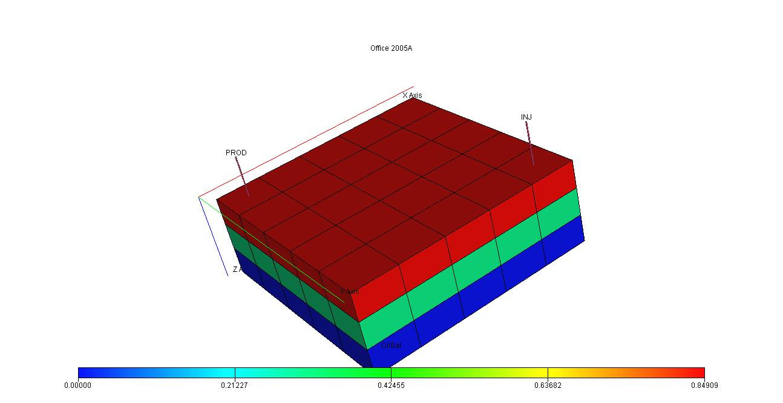

Figure 4.1 The 3D presentation of line drive flood pattern

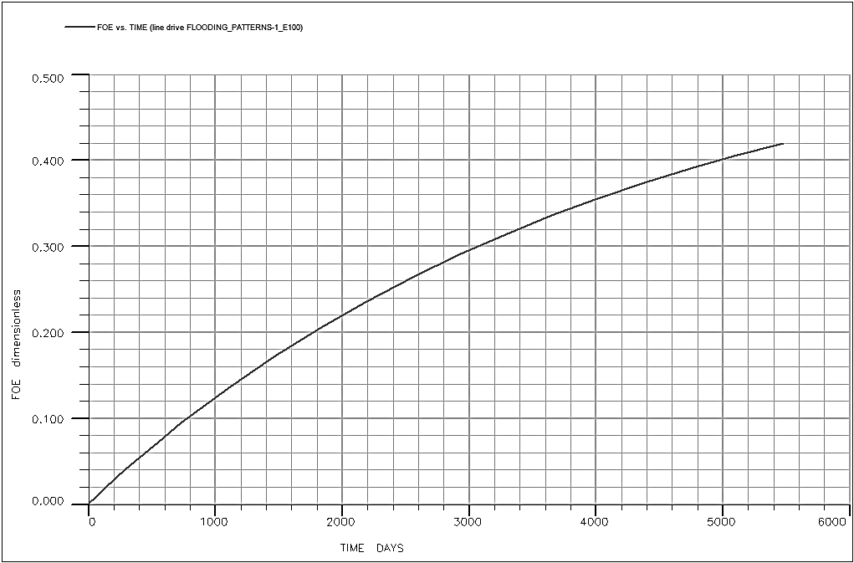

Figure 4.2 Graph of Field Oil Production Efficiency Against Time

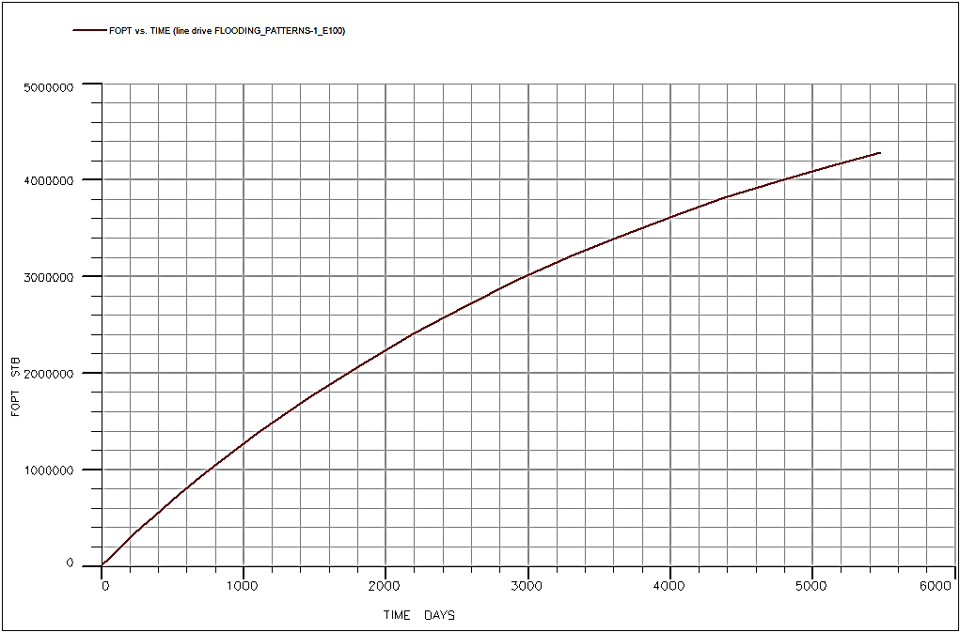

Figure 4.3 Graph of Field Total Oil Production against Time

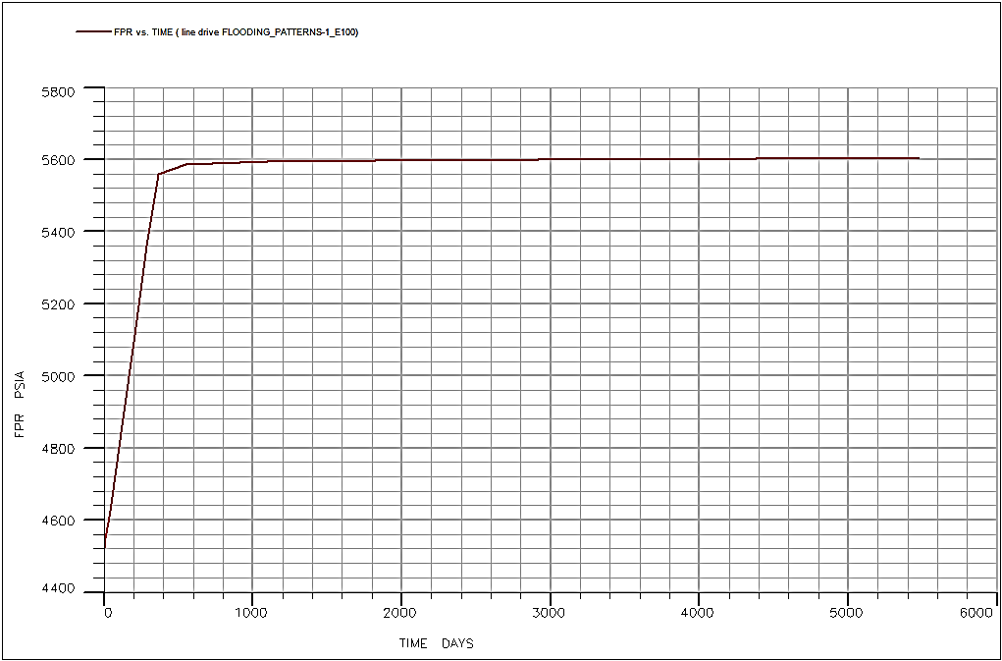

Figure 4.4 Graph of Field Pressure against Time

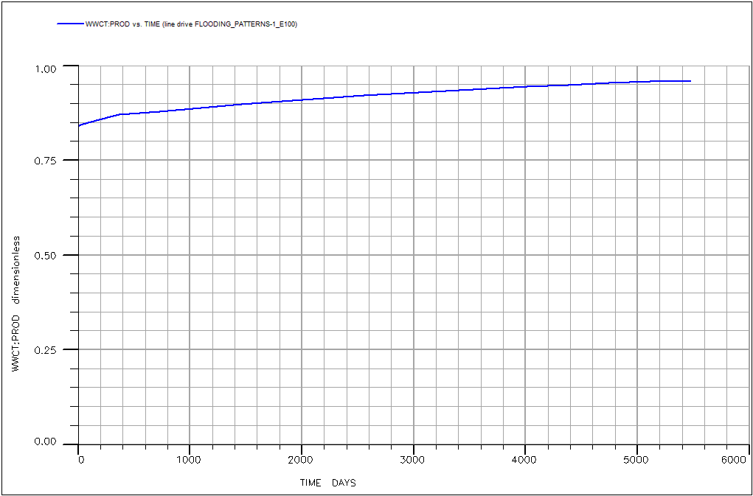

Figure4.5 Graph of Well Water Cut against Time

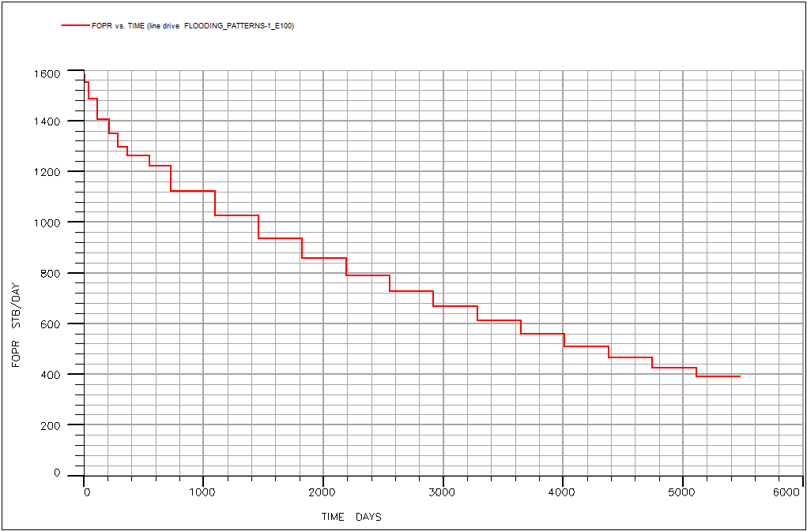

Figure 4.6 Graph of Field Oil Production Rate against Time

## **4.3 Results from 5-Spot Flooding**

This Contains Five Wells: Four Producer Wells And One Injector Well.

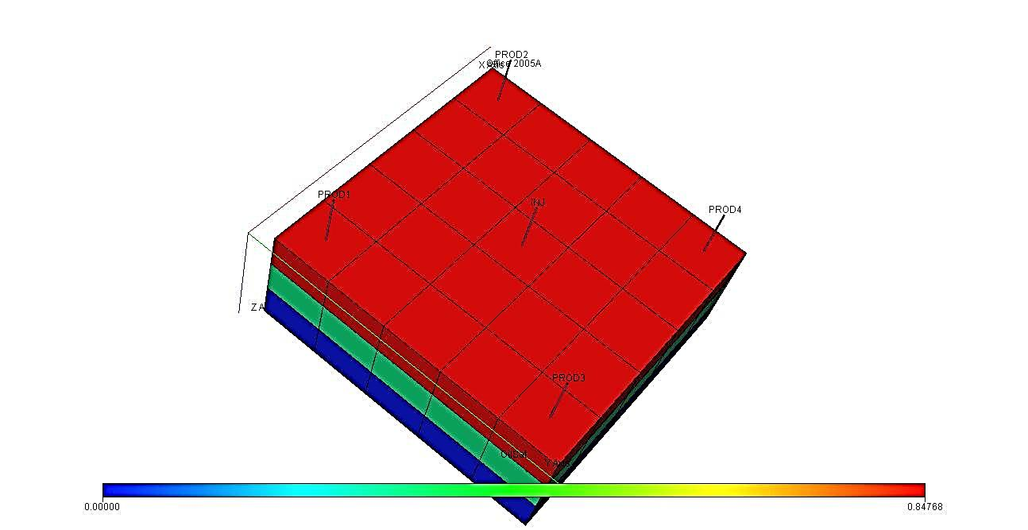

Figure 4.7 A 3D Presentation of 5-Spot Flood Pattern

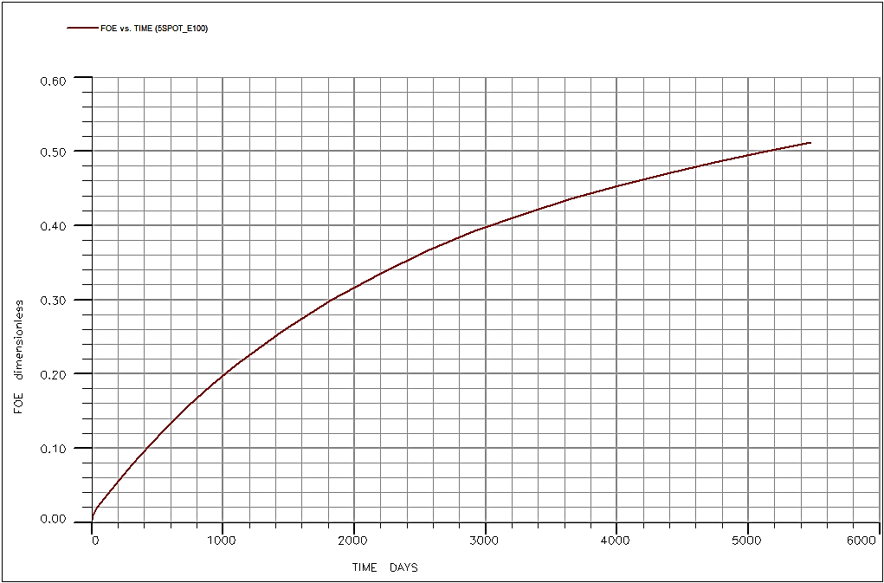

Figure 4.8 Graph Fidel Oil Production Efficiency against Time

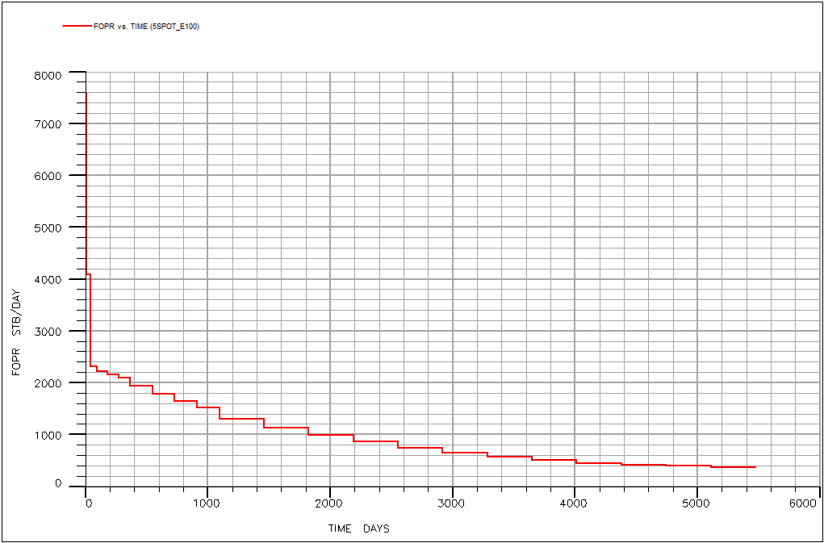

Figure 4. 9 Graph of Field Oil Production Rate against Time

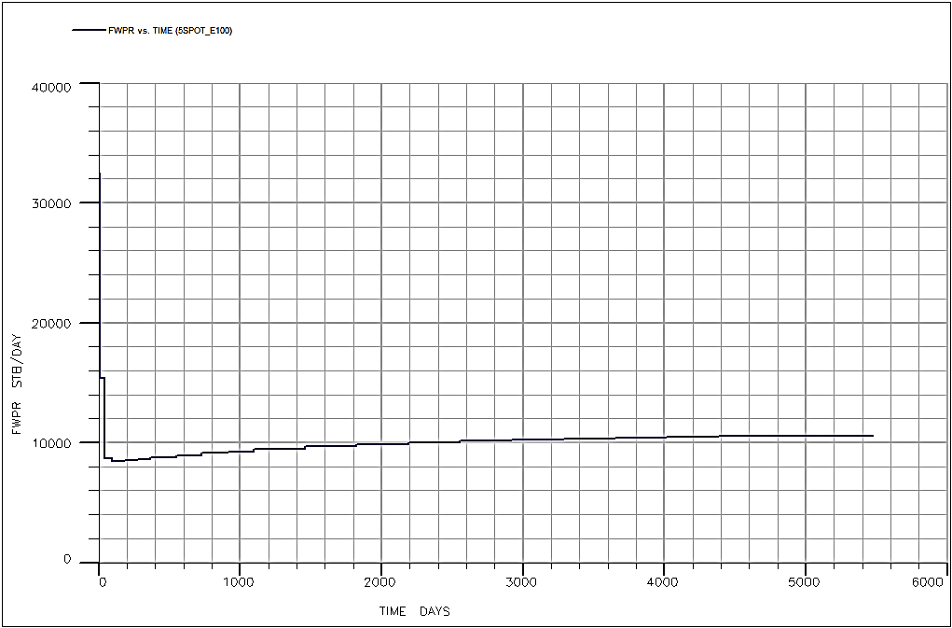

Figure 4.10 Graph of Water Production Rate against Time

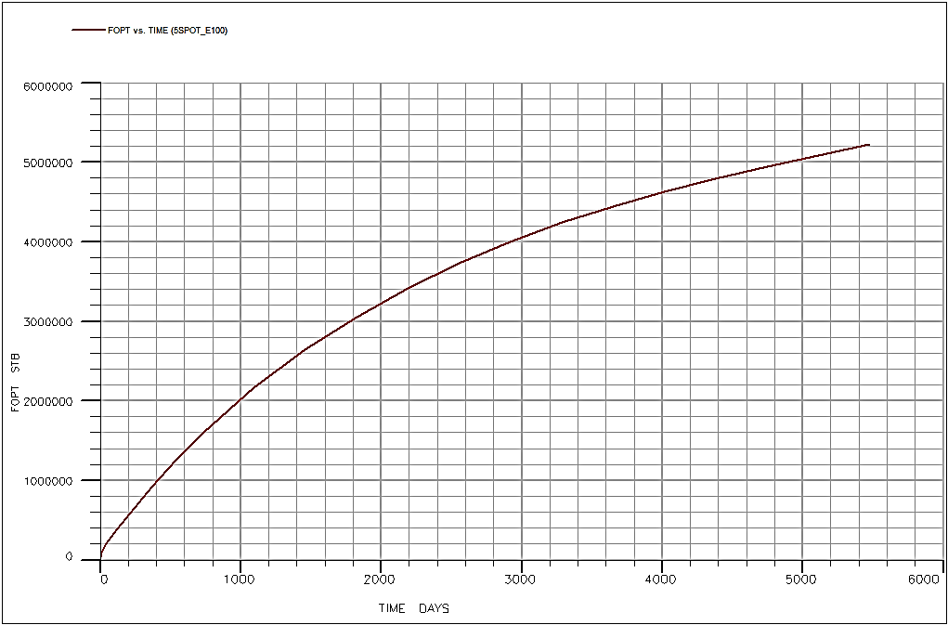

Figure 4.11 Graph of Field Total Oil Production against Time

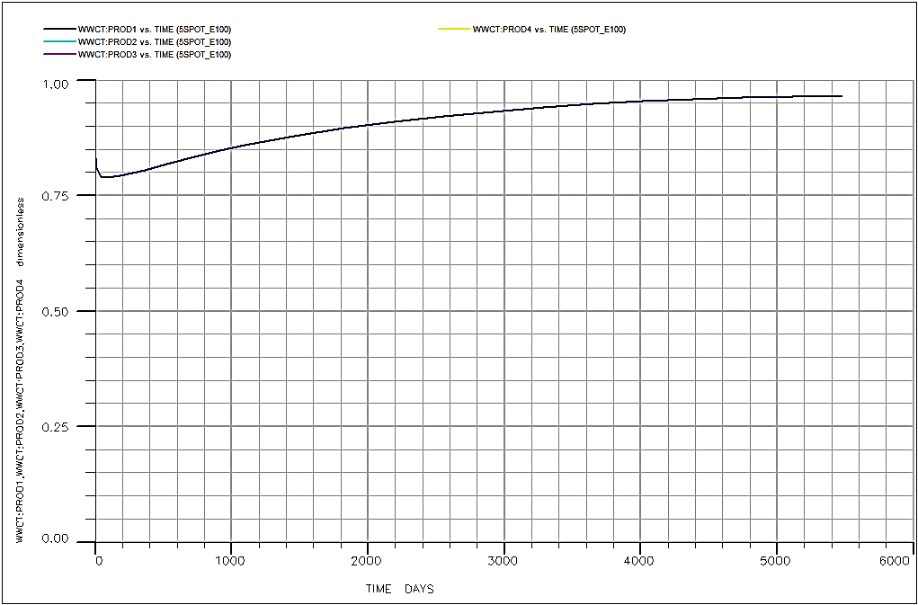

Figure 4.12 Graph of Well Water Cut against Time

## **4.4 Results from Skewed 4-Spot Flooding**

This Pattern Contains 6 Wells In Two Pattern Cycles: Four Injector And Two Producers.

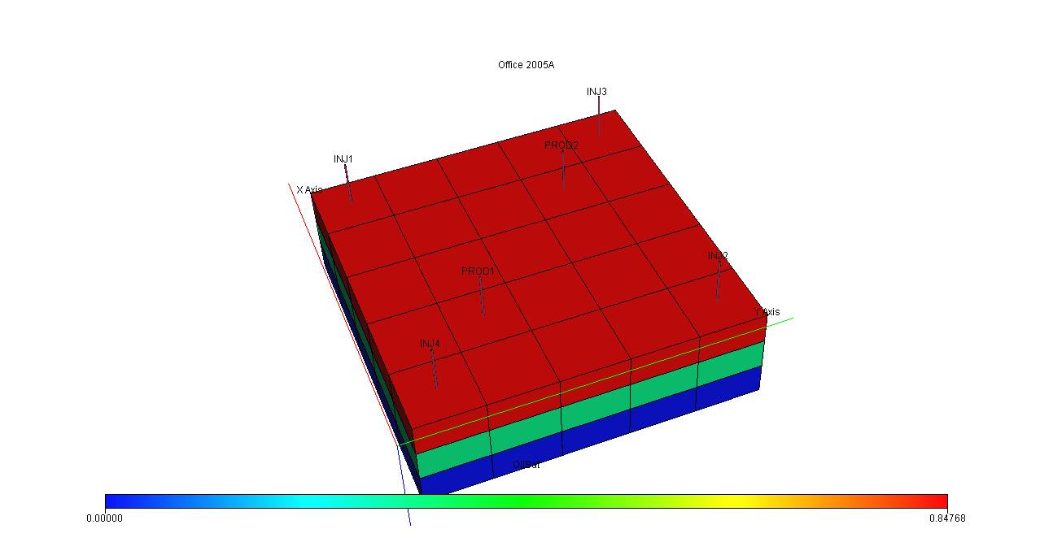

Figure 4.13 A 3D Presentation of a 4-Spot Flooding Pattern.

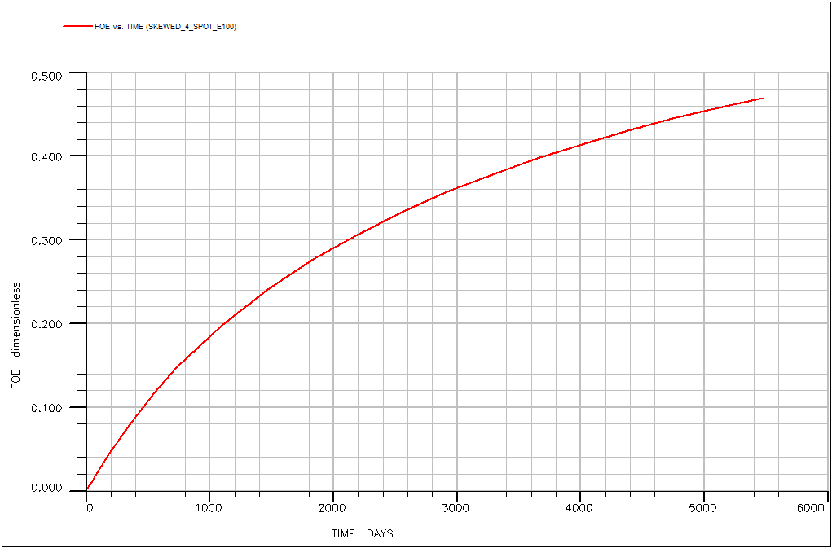

Figure 4.14 Graph Of Field Oil Production Efficiency Against Time

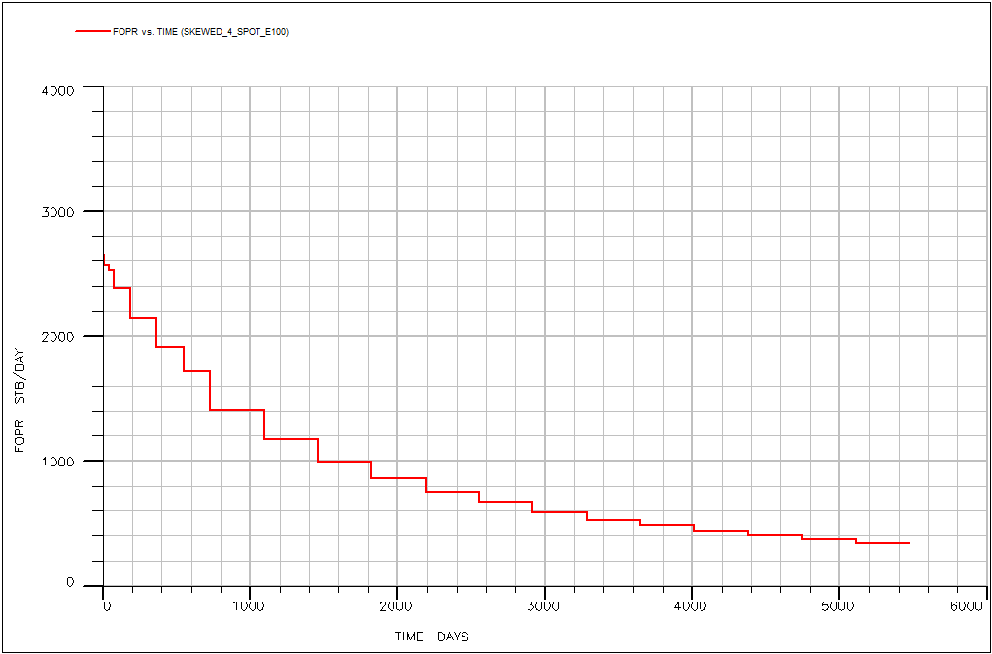

Figure 4.15 A Graph Of Field Oil Production Rate Against Time

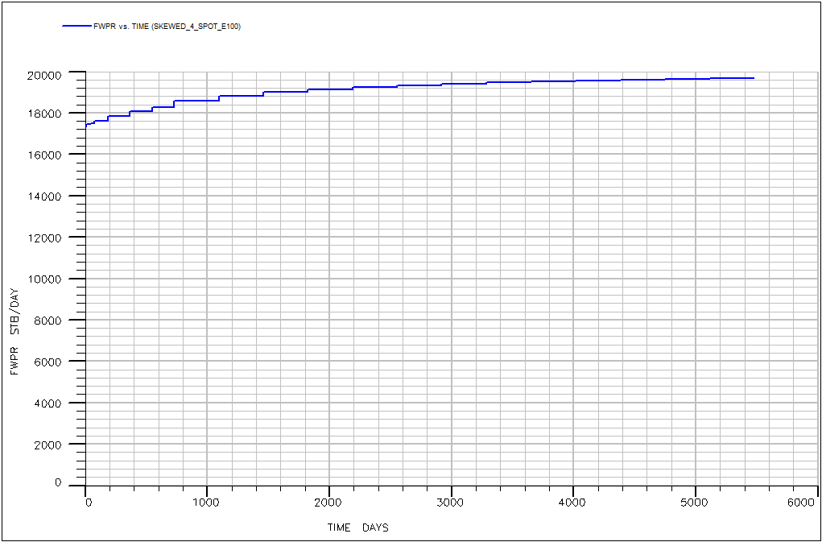

Figure 4.16 A Graph Of Field Water Production Rate Against Time

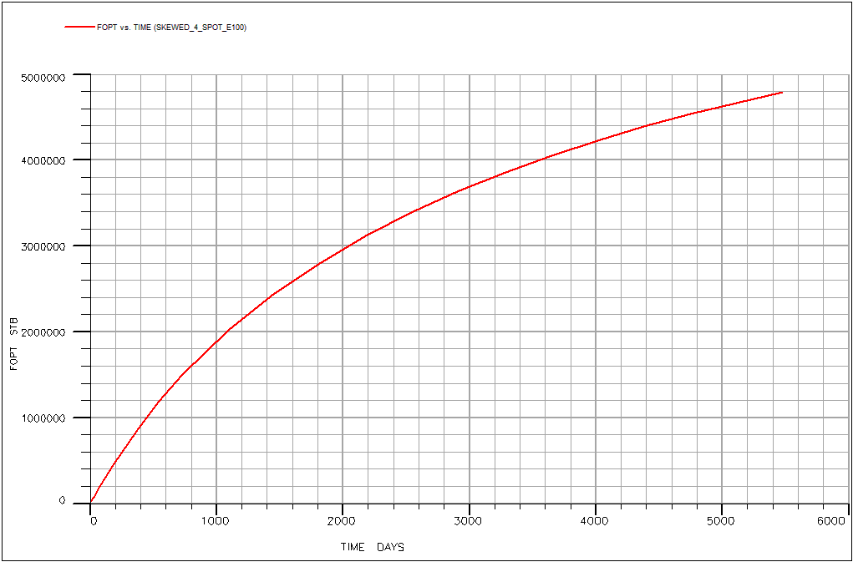

Figure 4.17 A Graph Of Total Oil Production Against Time

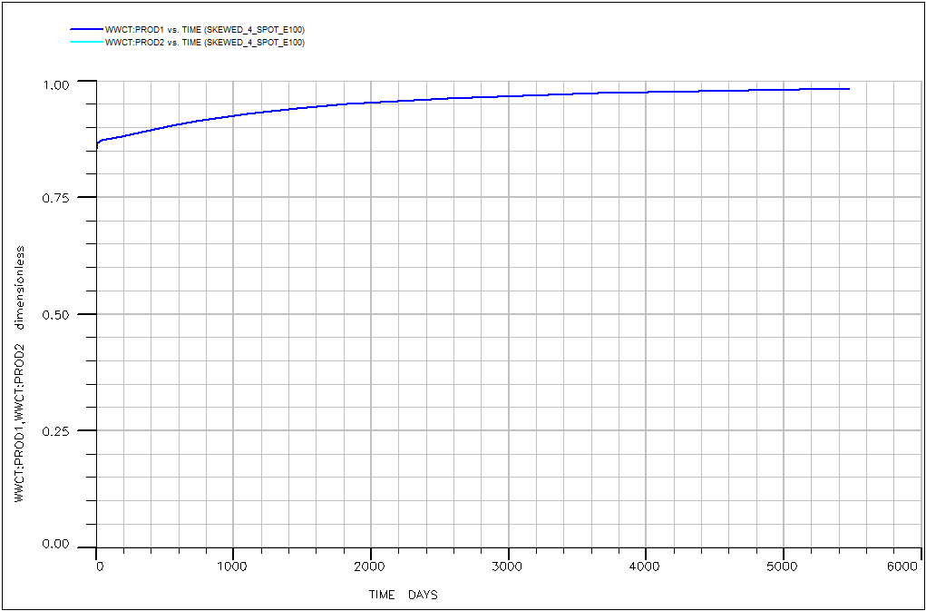

Figure 4.18 A Graph of Well Water Cut Against Time

## **4.5 Comparing the three flood patterns under investigation**

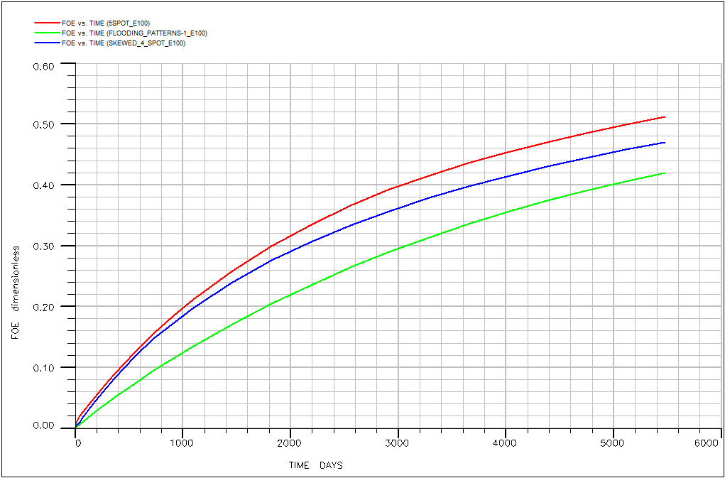

Figure 4.19 A Graphical Comparison Of The Production Efficiency Against Time For The Patterns Of Study

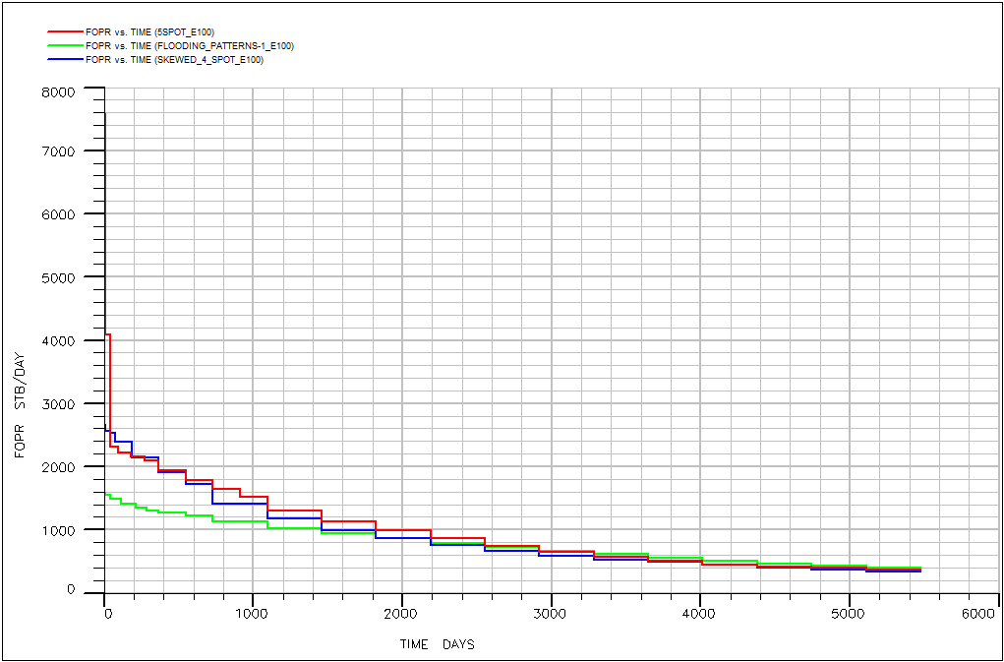

Figure 4.20 A Graphical Comparison Of The Oil Production Rates Against Time For The Patterns Of Study

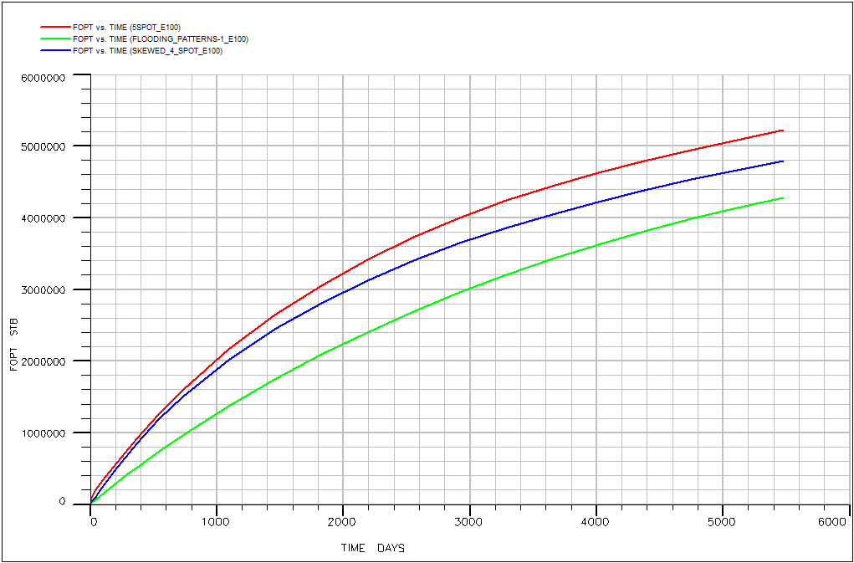

Figure 4.21 A Graphical Comparison Of The Total Production Against Time For The Patterns Of Study

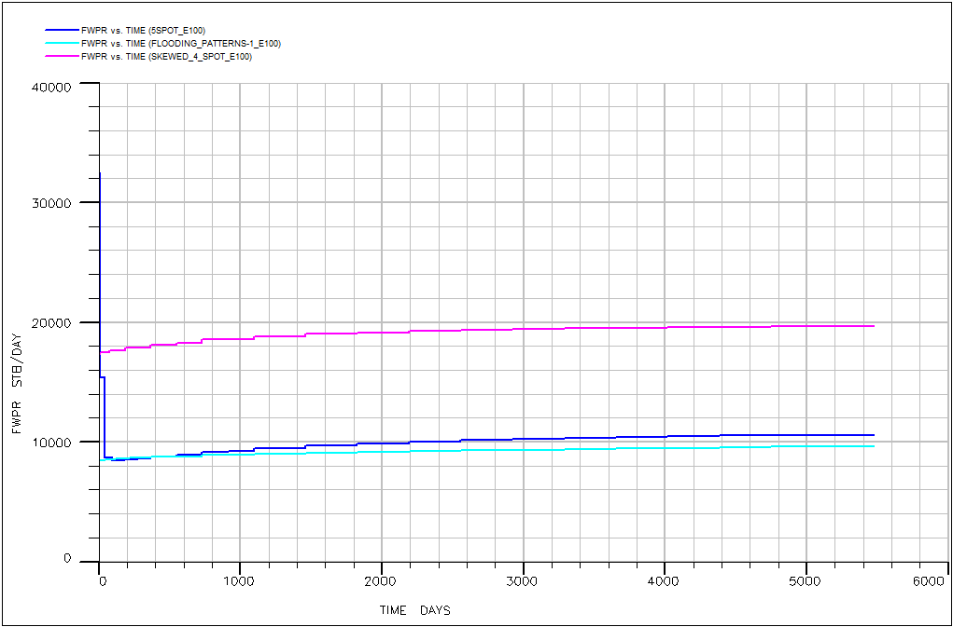

Figure 4.22 A Graphical Comparison Of The Water Production Rate Against Time For The Patterns Of Study

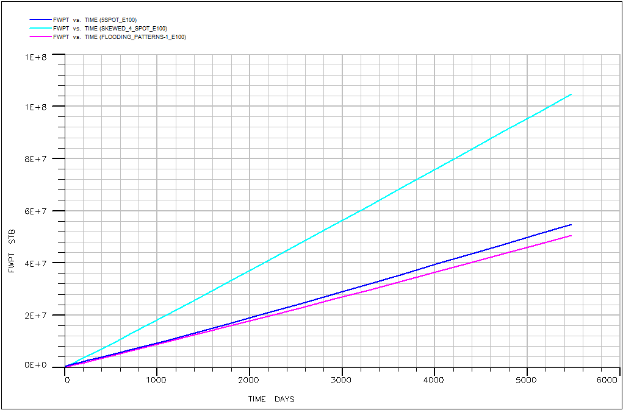

Figure 4.23 A Graphical C.Lomparison Of The Total Water Production Against Time For The Patterns Of Study

# **CHAPTER FIVE**

# **5.0 CONCLUSION AND RECOMMENDATION**

# **5.1 Conclusion**

Several inferences can be made from the results derived from the simulation and study. From the graphs of several parameters against the duration of flooding, critical decisions on the pattern of flooding to be implemented on this field and any other analogue field can be made with maximum precision.

The software, ECLLIPSE 100 was able to make complex calculations and predictions from the field data fed into the system.

## **5.1.1 Line drive**

From the results gotten, and from the comparative analysis carried out

* The line drive is the cheapest form of water flooding as it involves the minimum amount of wells to be drilled in a specific area of study.
* According to Fig 4.19 and Fig 4.21, it has the minimum recovery efficiency as it has the least total oil production.
* It seems to have a constant field water production rate
* It also has the least water production as only one injector well is required for a specific field area of study.
* It is very much more advisable where the oil in the field is not too heavy or viscous.

## **5.1.2 5-Spot flooding pattern**

From the results gotten after simulation and from the comparative analysis carried out on the field

* It is relatively the most economical flooding pattern possible on any field.
* From the comparative figures 4.19 and 4.21, 5-spot has the very highest oil production rate and cumulative oil production for the duration of study.
* It has a moderate cumulative water production and also a declining water production rate.
* Even though it has a high number of wells to be drilled per unit area of study, it is very profitable that it can sustain the costs with a satisfying profit.
* It has a very good pressure build up tendency for maximum recovery.
* It has the least risk of water encroachment.

## **5.1.3 Skewed 4-spot flooding pattern**.

From the results gotten during the simulation study, it can be inferred that:

* It is by far, the least economical flooding pattern.
* From the comparative figures 4.19 and 4.21, skewed 4-spot flooding pattern has oil production rate and cumulative oil production, though less than that of 5-spot flooding patter, but greater than that of line flood for the duration of study.
* It has an incremental water production rate with increase in time duration of flooding and has the highest cumulative water production for the period of 15 years.
* It has the highest risk of water encroachment and requires a lot of water handling facilities to be put in place.
* It is not advisable except the flow rate would be tailored to meet an optimum recovery parameter.

# **5.2 Recommendation**

Water flooding in the oil and gas industry is a very capital intensive project to embark on. The role of precision and minimum marginal figures cannot be overemphasized before starting up a water flooding project. So, it is very necessary that several parameters are evaluated before the project is commenced to achieve the desired maximum recovery from a field.

From the study carried out with the real field data as discussed in chapter three of this work, I recommend that the operators of the field consider the following:

* The field water flood project should resume within the first ten years of production from the field
* The flood pattern that will yield maximum recovery with the least volume of water to be injected is the 5-spot pattern.
* The 5-spot pattern will also reduce the risk of premature water breakthrough.
* Since the porosity of the field is low (0.19), the best water for this flooding is underground alluvial table water because it has little solid impurities and fines that may plug the pore spaces.

# **REFERENCES**

Alotaibi, M.B., Azmy, R.M., and Nasr-El-Din, H.A. 2010. A Comprehensive EOR Study Using Low Salinity Water in Sandstone Reservoirs. Paper SPE 129976, presented at the SPE Improved Oil Recovery Symposium, Tulsa, Oklahoma, 24-28 April.

Chen J. X., “Application of Advanced Water Flooding in Low Porosity and Permeability Oilfield,” Inner Mongulia Petrochemical Industry, No. 10, 2005.

Che Q. J., “Effects of Advanced Water Flooding in Extra-Permeability Oilfield Development,” Petroleum Geology and Oilfield Development in Daqing, Vol. 22, No. 1, 2003.

Delshad M., Asakawa K., Pope G. & Sepehrnoori K. "Simulations of Chemical and Microbial Enhanced Oil Recovery Methods." SPE Paper 75237 presented at the SPE/DOE Improved Oil Recovery Symposium. Tulsa, Oklahoma, 13-17 April: Society of Petroleum Engineers Inc., 2002.

Green D. W. & Willhite G. P. Enhanced Oil Recovery. Richardson, Texas: Society of Petroleum Engineers, 1998.

http://www.safehaven.com/article/5639/energy-insights (accessed April 6, 2012).

Jadhunandan, P. and Morrow, N.R. 1995. Effect of Wettability on Waterflood Recovery for Crude Oil/Brine/Rock Systems. SPE Reservoir Engineering, February: 40-46.

Lake L. W. "Enhanced Oil Recovery." SPE ATCE. Training Courses. Florence, Italy: Society of Petroleum Engineers, September 23, 2010.

Lake L. W. Enhanced Oil Recovery. Englewood Cliffs, New Jersey: Prentice Hall, 1989.

Li. M. Kang et al., “Timing of Rational Advanced Water Injection and Limit Water Injection,” Henan Petroleum, Vol. 17, No. 6, 2003.

Lyons W. & Plisga, B. S. (Eds). Standard Handbook of Petroleum & Natural Gas Engineering (Second edition). Burlington, MA: Elsevier Inc., 2005

McGuire, P.L., Chatham, F.R., Pahvan, F.K., Sommer, D.M., and Carini, F.H. 2005. Low Salinity Oil Recovery: An Exciting New EOR.

Muruaga E., Flores M., Norman C. & Romero J. "Combining Bulk Gels and Colloidal Dispersion Gels for Improved Volumetric Sweep Efficiency in a Mature Waterflood." SPE Paper 113334 presented at the 2008 SPE/DOE Improved Oil Recovery Symposium. Tulsa, Oklahoma, U.S.A., 19-23 April: Society of Petroleum Engineers, 2008.

Ohms, D. et al, "Incremental-Oil Success From Waterflood Sweep Improvement in Alaska." SPE Production & Operations, 25 (3), August 2010: 1-8.

Robertson, E.P., Thomas, C.P., Zhang, Y, and Morrow N.R. 2003. Improved Waterflooding through Injection-Brine Modification. Idaho National Laboratory External Report No. INEEL/EXT-02-01591, Idaho Falls, ID (January 2003).

Regtien J. M. M. "Extending The Smart Fields Concept To Enhanced Oil Recovery." SPE Paper 136034 presented at the 2010 SPE Russian Oil & Gas Technical Conference and Exhibition. Moscow, Russia, 26-28 October: Society of Petroleum Engineers, 2010. 1-11.

Taber J. J., Martin F. D. & Seright, R. S. "EOR Screening Criteria Revisited-Part 1: Introduction to Screening Criteria and Enhanced Recovery Field Projects." SPE Reservoir Engineering, 12 (3) August 1997.

Tang, G.Q. and Morrow, N.R. 1997. Salinity, Temperature, Oil Composition, and Oil Recovery by Waterflooding. SPE Reservoir Engineering, November: 269-276.

Tang, G.Q. and Morrow, N.R. 1999. Influence of brine composition and fines migration on crude oil/brine/rock interactions and oil recovery. Journal of Petroleum Science and Engineering **24**

Tang, G.Q. and Morrow, N.R. 2002. Injection of Dilute Brine and Crude Oil/Brine/Rock Interactions. Geophysical Monograph 129: 171-179.

Wang Y. D. et al., “Advance Water Injection in Reverse Nine-Spot Well Pattern in Block 119 of Xinli Oilfield,” Journal of Oil and Gas Technology, Vol. 29, No. 6, 2007.

Yildiz, H.O., and Morrow, N.R. 1996. Effect of Brine Composition on Recovery of Moutray Crude Oil by Waterflooding. J. Pet. Sci. Eng, May, Vol. 14

Yang H. et al, "Low-cost, High -Performance Chemicals for Enhanced Oil Recovery." SPE paper 129978 presented at the 2010 SPE Improved Oil Recovery Symposium. Tulsa, Oklahoma, U.S.A., 24-28 April: Society of Petroleum Engineers, 2010.

Zaitoun A. et al., "Shear Stability of EOR Polymers." SPE Paper 141113 presented at the 2011 SPE International Symposium on Oilfield Chemistry. The Woodlands, Texas, U.S.A., 11-13 April: Society of Petroleum Engineers, 2011.

Zhang Z. Y. et al., “Research and Application on Technology of Advance Water Flooding in Guyunji Oilfield,” Special Oil and Gas Reservoirs, Vol. 14, No. 5, 2007.

Zhao L. et al., “Utilizing Advanced Water Injection to develop Low Permeability Pool,” Fault-Block Oil and Gas Field, Vol. 10, No. 3, 2003

Zhuang J. and Q. Wu, “The Application and Practice of Advanced Water Injection in Low Permeability Reservoir of XinLi,” Special Oil and Gas Reservoirs, Vol. 12, No. 3, 2005